**Lab 10 – Complex Numbers**

**Objectives**

• Understand complex numbers and their relationship with reality

# Background

*"That this subject (imaginary numbers) has hitherto been surrounded by mysterious obscurity, is to be attributed largely to an ill-adapted notation. If, for instance,* *had been called direct, inverse and lateral units, instead of positive, negative and imaginary (or even impossible) then such an obscurity would have been out of the question.”*

-Carl Friedrich Gauss (1777-1855)

This quote from Gauss is a good place to start in our exploration of what complex numbers mean and how they are useful to mathematicians, scientists and engineers. From the very earliest use of these concepts, confusion has abounded as to what an imaginary number actually is and how it is useful. By relating as much as possible to real signals and their manipulation, this lab hopes to clarify and consolidate the understanding for the student about complex numbers.

Consider a complex number, *A*, consisting of a real part, *a*, and an imaginary part, *jb*. The imaginary value  is represented by the letter *j*, so *j* = √−1 and *j2* = -1. The complex number may be written in

rectangular form as *A = a + jb*.

Let’s do a few simple math exercises with complex numbers. Suppose *A = 1 + j3* and *B = 2 + j4*:

*A + B = (1 + 2) +j(3 + 4) = 3 + j7*

*AB = (1 +j3)(2+j4) = (1)(2) +(1)(j4) + (j3)(2) + (j3)(j4)=2+j4+j6-12=-10+j10*

---------------------------------------------------------------------------------------------------------------------------------- Exercise: Suppose *A = 1 - j1* and *B = 2 + j1*. Calculate (a) *A + B*, (b) *AB*. (Not required. Was not in red)

---------------------------------------------------------------------------------------------------------------------------------- A quick note here regarding the use of “*j*” to represent the imaginary part of a complex number. Although in general mathematics the imaginary part of a complex number is identified by the letter "*i*", in electrical engineering in order to avoid confusion with the symbol for current "*i*", the symbol for the imaginary part of a complex number uses the letter "*j*". As there is much overlap between mathematics and electrical engineering, you will at time find these symbols used interchangeably.

Fig.1: Diagram of a complex number

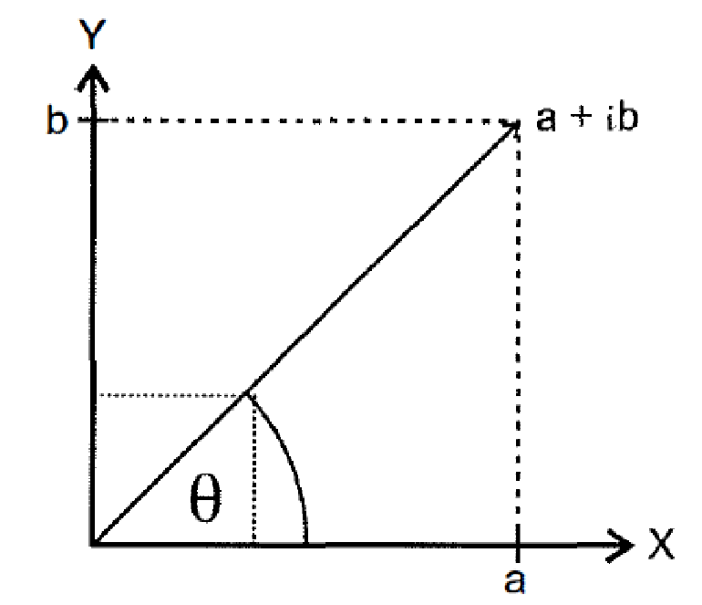

A complex number can be represented as a point on a graph such as Figure 1. Here, the horizontal axis is for real values and the vertical axis is for imaginary values. A vector may be drawn from the origin to the complex point. The complex number may be expressed in polar form, *A = |A|ej*θ, where *|A|* is the magnitude of the vector and θ is the angle the vector makes with the positive real axis. This representation applies Euler’s equation:

𝑒𝑒𝑗𝑗𝑗𝑗 = 𝑐𝑐𝑐𝑐𝑐𝑐𝑐𝑐 + 𝑗𝑗𝑐𝑐𝑗𝑗𝑗𝑗𝑐𝑐

Now, for our vector *A = a + jb*, |A| = √𝑎𝑎2 + 𝑏𝑏2, and *tan*θ *= b/a*, or θ *= tan-1(b/a).* Consider *A =* 1 + j1.

Then *|A| =*  = 45◦.

Note that calculating θ requires attention from the user. Suppose *A = 1 –j1* and *B = -1 + j1*. Calculating θ we find θ*A* = tan-1(-1/1) and θ*B* = tan-1(1/-1). Your calculator may not know the difference, but a quick plot of the vectors reveals a 180◦ difference between the two angles.

---------------------------------------------------------------------------------------------------------------------------------- Exercise: For each of the following complex numbers, draw the vector on a graph similar to Figure 1 and express each vector in polar form.

1. 3 + j4

1. 3 – j4

1. -3 + j4

1. –3 – j4

---------------------------------------------------------------------------------------------------------------------------------- Euler’s equation is often used to represent a sinusoid in phasor notation:

𝐴𝐴 cos(𝜔𝜔𝜔𝜔 + 𝑐𝑐)= 𝑅𝑅𝑒𝑒𝐴𝐴𝑒𝑒𝑗𝑗(𝜔𝜔𝜔𝜔+𝑗𝑗) = 𝑅𝑅𝑒𝑒𝐴𝐴𝑒𝑒𝑗𝑗𝑗𝑗𝑒𝑒𝑗𝑗𝜔𝜔𝜔𝜔 where the “*Re*” indicates we take the real part (not the imaginary part) of the brackets interior. The *phasor* representation is then:

𝐴𝐴𝑆𝑆 = 𝐴𝐴𝑒𝑒𝑗𝑗𝑗𝑗

The phasor is a static representation that removes the time dependence, and you can imagine this phasor to be a vector on a complex number plot such as Figure 1. It is useful to keep in mind, though, that the vector is rotating counterclockwise on this plot at the rate ω radians per second.

# Part A – Sinusoids as Complex Numbers

This experiment shows the relationship between sinusoidal signals and complex numbers. As usual, we will observe the “scope view”, which is the classic sinusoidal transient plot that students are quite familiar with. But we will also examine the “XY view” of a pair of sinusoids.

# A.1 Phasor Diagram

Fig. 2: initial TIMS rack configuration for complex number study

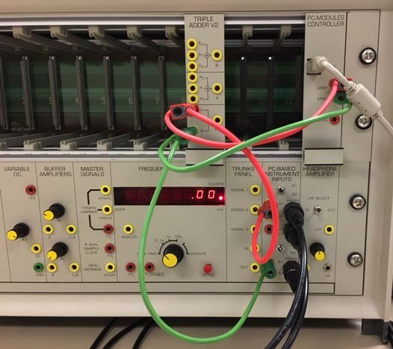

1. Insert the TRIPLE ADDER V2 module into the TIMS rack (see Figure 2).

• Note the slot number where the module is inserted.

1. Connect the PC MODULES

CONTROLLER ARB1 output to the TRIPLE ADDER’s f input and to Scope ChA (red leads).

1. Connect the ARB2 output to the g input of the adder and to Scope ChB (green leads).

1. Turn on the PicoScope

* Turn on ChB
* AC couple both channels and for now leave them both in Auto Scale
* Set the time scale to 2ms/div
* Set trigger to auto and adjust the trigger point as needed to stabilize the figure. If necessary use single shot triggering.

Fig. 3: initial SFP configuration for complex number study

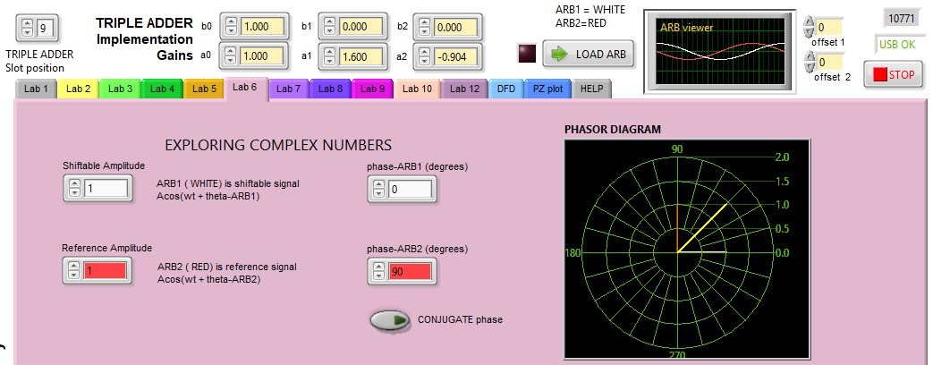

5. Turn on the SFP (See Figure 3)

* Select Lab 6 and enter the appropriate Triple Adder slot position
* Set ARB1 to 1sin(ω*t*) (Shiftable Amplitude 1 and 0◦ phase shift)
* Set ARB2 to 1sin(ω*t* +90◦) (amplitude 1 and 90◦ phase shift)
* Study the SFP’s phasor diagram. The ARB1 green vector in the figure is at 1+j0 on the diagram, and the ARB2 red vector is at 0+j1. Express the summed value (yellow vector) as a complex number:

Sum = ARB1+ARB2 = 1 + j

6. Now press the SFP’s LOAD ARB button and observe what happens on the PicoScope (see Figure 4).

Fig. 4: Transient view of ARB1 (blue) and ARB2 (red) sinusoids

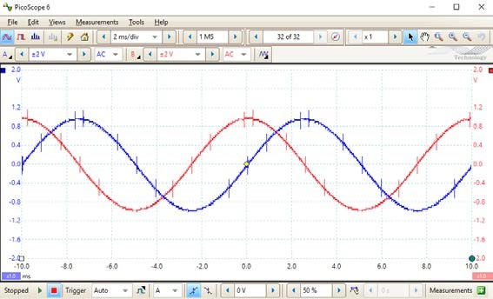

* Set ChA and ChB scales to +/- 2V
* You may need single shot triggering to view the traces

1. What do you think will happen to the PicoScope display and the phasor diagram if the ARB2 phase is changed to -90◦?

1. Change the ARB2 phase to -90◦, press “Load ARB”, and record the complex number for the summed value: 1 - j

# A.2 XY View

We will now set up the XY view which is most instructive if the window and the scales are set to provide a square display.

Fig. 5: Preparing PicoScope to display 2

nd

window

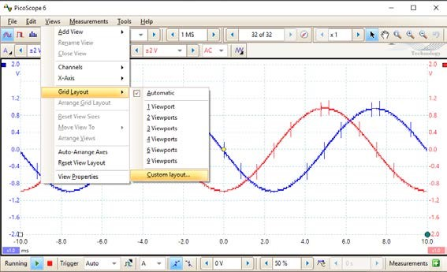

Fig. 6: Adding XY view to PicoScope display

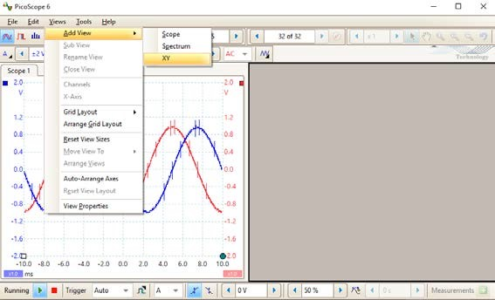

Fig. 7: Scope and XY views for two sinusoids (ARB1 and ARB2) that

are out of phase by 90

◦

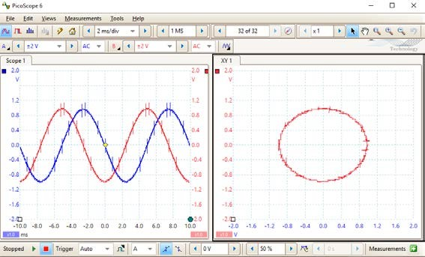

1. On the PicoScope, select Views → Grid

Layout → Custom Layout (see Figure 5)

• Select 1 row and 2 columns

1. Now select Add View → XY (Figure 6)

1. Figure 7 displays both the scope and the XY views for the pair of ARB sinusoidal signals.

• Make sure the scales are the same for each channel. Here, +/- 2V is used.

Q: Can you explain why the XY plot displays a circle? Because it is shown the wave on the XY plane. The sine waves pass through all of the values

4. Disconnect ARB1 from Scope ChA and observe the scope and XY views for only ARB2 (see Figure 8).

Fig. 8: viewing only ARB2 on Scope and XY views

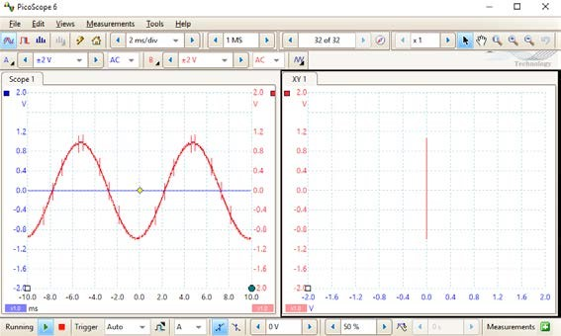

• Recall from Section A.1 step 5 that the red vector representing ARB2 can be written 0 + j1. How does this correspond to what you see on the PicoScope? Straight line vertical because blue is zero. Only showing + and – j direction which is just the y value plane

5. Reconnect ARB1 to ChA. Now disconnect ARB2 from Scope ChB. Observe the scope and XY views for only ARB1 (see Figure 9).

Fig. 9: viewing only ARB1 on Scope and XY views

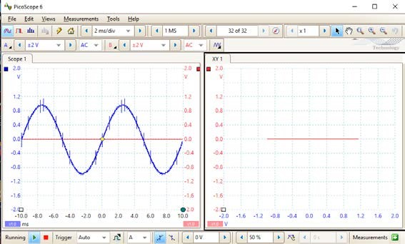

• Recall from Section A.1 step 5 that the green vector representing ARB1 can be written 1 + j0. How does this correspond to what you see on the PicoScope? Straight line horizontal because the red line is constantly zero. Only showing +1 nad -1 which is the x values

Fig. 10: Scope and XY views for ARB1 and ARB2 set up as indicated

in step 6

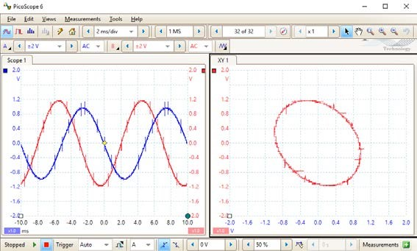

6. Reconnect ARB2 to Scope ChB. Vary the Triple Adder’s settings in the SFP as follows:

* Ref amplitude ARB1= 1; Phase = -15◦
* Ref amplitude ARB 2 = 1.2; Phase= 75◦
* Press “Load ARB” and observe the scope and XY views (Figure 10).

Write the equation for signals at ARB1 and ARB2 as a function of time in the form:

Acos(ω*t* + θ)

ARB1: 1cos(wt-15deg)

ARB2: 1.2cos(wt + 75deg)

7. Return the Triple Adder settings back as follows:

* Ref amplitude ARB 1 = 1; Phase= 0◦
* Ref amplitude ARB 2= 1; Phase= 90◦
* Press “Load ARB”

1. Leave the ChA scope lead connected to ARB1 output and move the ChB scope lead to the output of the adder "f+g". You are now viewing the sum of the two sinusoids (see Figure 11).

Fig. 11: Scope and XY views for ARB1 and ARB2 set up as indicated

in step 7

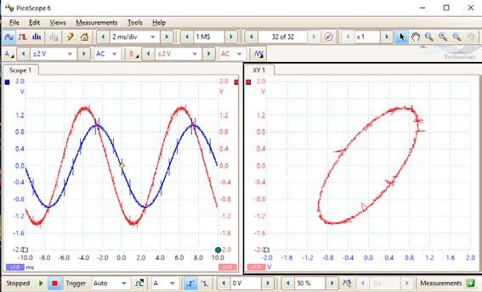

1. Do not change the wiring on the TIMS, you will need it in Part C.

# B.1 Complex Numbers and MATLAB

In MATLAB you can represent complex numbers with the variable ***j***, or ***i***. Try typing the command below to learn how MATLAB works with complex numbers. Observe how MATLAB returns the value of the variable x if you call it, and view the variable x in the workspace window.

>> x = 1+ 2*j;

MATLAB only processes complex numbers in rectangular form. If you need to get a phasor representation out of MATLAB a few functions are required. The function **abs()** returns the magnitude of a complex number. The MATLAB function **angle()** returns the angle 𝑐𝑐 in radians as referenced in Figure 1. Some other helpful MATLAB functions are **rad2deg()** and **deg2rad()**, which convert radians to degrees and vice versa.

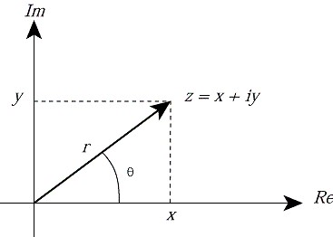

*Figure 1: Polar Plot of Complex Number [1]*

If you would like to input complex numbers into MATLAB using polar form, you can use the following syntax. The variable names correspond to the labels in Figure 1 and theta is in radians. This method comes from Euler’s identity.

>> Z = r*exp(j*theta);

For the sake of the exercise below, you can represent the polar representation of a complex number by using an array as follows.

>> x = [r, theta];

Where r and theta are as referenced in figure 1. This will not be recognized as a complex number in MATLAB, but is a convenient way to display what the complex value is in polar form. This notation is not innate to MATLAB. It is simply the way we are defining the data representation for this lab exercise.

# B.2 MATLAB Exercise

With your lab partner, generate 2 separate MATLAB functions described below:

* [z] = pol2rec(x); - aka polar to rectangular formo This function should take the variable x, which is represented in the polar form defined above, and convert it to a MATLAB complex variable z in rectangular form.o HINT: you will want to use 𝑍𝑍̅ = 𝑟𝑟 ∙ 𝑒𝑒𝑗𝑗𝑗𝑗
* [x] = rec2pol(z); - aka rectangular to polar formo This function should take the variable z, which is a complex number in MATLAB, and convert it to the polar representation, x, defined above
  + Represent theta in degrees.
  + Print the polar value out on the command like the text below.

“R /_ theta (degrees)”

Use the function fprintf() and use MATLAB documentation to learn how to display text that involves variables values like above.

You can verify that your functions work by passing a number through both functions sequentially and seeing if you end up with the same value that you started with. Have your TA check the functions.

# C TIMS and MATLAB Combined

The TIMS should be setup as in the end of part B.

1. Measure and document the magnitude and phase of the sum of the two sinusoids on the scope. Compare this with the expected result, calculated using the phasor method and MATLAB.

* Convert the two sinusoids to phasors. The equations are your answers for ARB1 and ARB2 in step 6 above.
* Use the MATLAB functions that you created to add the two phasors.

2. You should still have the setup from step 8

* Scope ChA should be connected to the ARB1 output
* Scope ChB should be connected to the output of the adder “f+g”.

3. Vary the arbitrary waveform generator settings in the SFP as follows:

* Ref amplitude ARB1= 1; Phase =0◦
* Ref amplitude ARB 2 = 1.2; Phase= 180◦
* Press “Load ARB” and observe the scope and XY outputs

4. Make another variation on the SFP:

* Ref amplitude ARB 2 = 1.2; Phase= -180◦
* Press “Load ARB” and observe the scope and XY outputs

Q: Comparing the output sum signals from steps 11 and 12, are the results as expected? Explain.

Yes bc even though the sine wave flips, the result remains the same.

# D Conjugate Signals

Consider again the complex number *A* = *a + jb* = |*A*| e*j*θ

The complex conjugate of *A* is expressed as *A\** and can be written *A\** = *a - jb* = |*A*| e*-j*θ

Notice that the sum of A and A* is simply 2*a*, as the imaginary parts cancel. Likewise, the product of A and A* is |A|2 as once again the imaginary parts cancel.

In this part of the lab we will experiment with conjugate signals.

1. Continue with the TIMS setup from before.

* Connect ARB1 to the Triple Adder’s f input and to Scope ChA.
* Connect ARB2 to the Triple Adder’s g input.
* Connect the Triple Adder’s “f+g” output to Scope ChB.

2. Vary the Triple Adder’s settings in the SFP as follows (Figure 12):

* Ref amplitude ARB1= 1;
* Ref amplitude ARB 2 = 1; Phase= 20◦
* Set the Conjugate Phase mode switch to ON

1. Setting Conjugate Phase mode ON will automatically set the relative phase of the ARB1 signal to be the negative of the phase of the ARB2 signal. That is, ARB1 will output a signal conjugate to that of ARB2. Both phasors will be symmetrical about the real axis. And the imaginary part of the sum will cancel, leaving only the real part.

Fig. 12: SFP setup for step 2

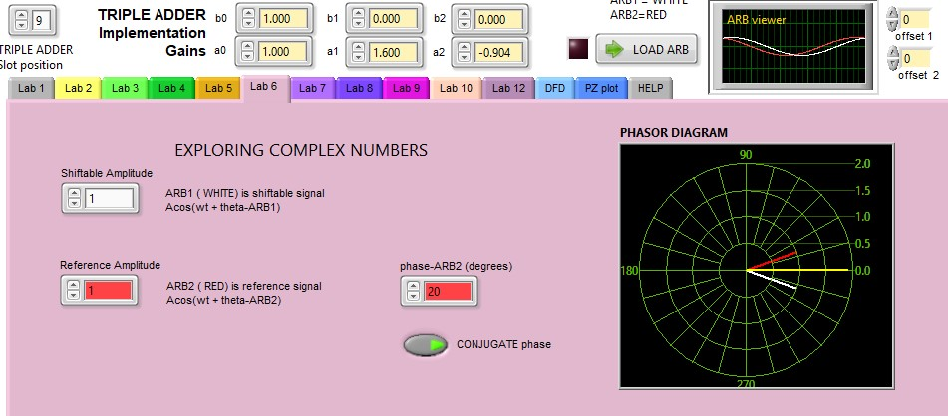

1. On the SFP, vary the ARB2 phase setting and observe the phasor plot showing the phasors moving relative to each other. Bear in mind that the sum of these two vectors will fall on the real axis and inscribe a real signal.

(

a)

(

b)

(

c)

Fig. 13: (a) First step in adding a measurement to read the

peak value of f+g. (b) setting measurement to read max of

Channel B. (c) Min and Max of B shown at bottom of scope

display.

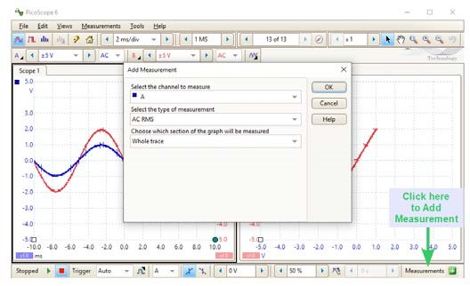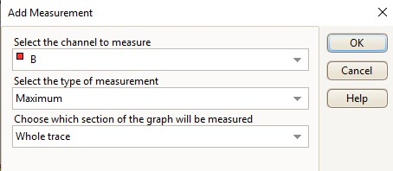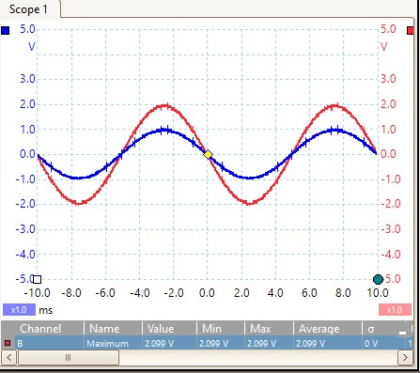

1. Set up the PicoScope to read the peak amplitude value of the “f+g” sum.

• First, add a measurement by clicking on the tab at the lower right of the PicoScope display as indicated in Figure 13a.

6. Set Channel to measure as B and the type of measurement to Maximum (See Figure 13b).

* Ensure both Picoscope channels are set for AC coupling to eliminate any DC component in the signals.
* The result in Figure 13c indicates the amplitude of the output signal B at the bottom of the Scope display.

1. If you ever need to delete an entry in the measurement bar, highlight the bar with your cursor and press ‘Delete’ on your keyboard.

Fig. 14: deleting a measurment

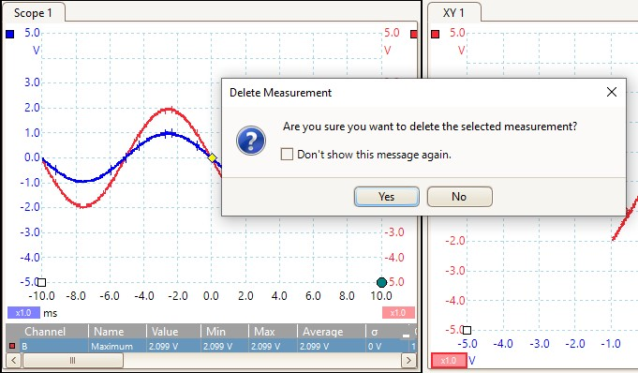

You’ll get the message shown in Figure 14.

1. Vary the ARB2 phase from 0 – 360 degrees in 30 degree steps and record the ChB amplitude in Table 1. The first one is done for you.

Table 1

|  |  |
| --- | --- |
| Phase (degrees) | Output signal amplitude  (V) |
| 0 | 2.0 |
| 30 | 1.7 |
| 60 | 1.1 |
| 90 | 0.2 |
| 120 | 1.0 |
| 150 | 1.7 |
| 180 | 2.0 |
| 210 | 1.7 |
| 240 | 1.1 |
| 270 | 0.2 |
| 300 | 1.0 |
| 330 | 1.7 |
| 360 | 2.0 |

1. Use either MATLAB or the blank graph of Figure 15 to plot your Table 1 results. This should go in your lab notebook.

|  |  |  |  |  |  |  |  |  |  |  |  |  |  |  |  |  |  |  |  |  |  |  |  |  |  |  |  |  |  |  |  |  |  |  |  |  |  |  |  |  |  |  |  |  |  |  |  |  |  |  |  |  |  |  |  |  |  |  |  |  |  |  |  |  |  |  |  |  |  |  |  |  |  |  |  |  |  |  |  |  |  |  |  |  |  |  |  |  |  |  |  |  |  |  |  |  |  |  |  |  |  |  |  |  |  |  |  |  |  |  |  |  |  |  |  |  |  |  |  |  |  |  |  |  |  |  |  |  |  |  |  |  |  |  |  |  |  |  |  |  |  |  |  |  |  |  |  |  |  |  |  |  |  |  |  |  |  |  |  |  |  |  |  |  |  |  |  |  |  |  |  |  |  |  |  |  |  |  |  |  |  |  |  |  |  |  |  |  |  |  |  |  |  |  |  |  |  |  |  |  |  |  |  |  |
| --- | --- | --- | --- | --- | --- | --- | --- | --- | --- | --- | --- | --- | --- | --- | --- | --- | --- | --- | --- | --- | --- | --- | --- | --- | --- | --- | --- | --- | --- | --- | --- | --- | --- | --- | --- | --- | --- | --- | --- | --- | --- | --- | --- | --- | --- | --- | --- | --- | --- | --- | --- | --- | --- | --- | --- | --- | --- | --- | --- | --- | --- | --- | --- | --- | --- | --- | --- | --- | --- | --- | --- | --- | --- | --- | --- | --- | --- | --- | --- | --- | --- | --- | --- | --- | --- | --- | --- | --- | --- | --- | --- | --- | --- | --- | --- | --- | --- | --- | --- | --- | --- | --- | --- | --- | --- | --- | --- | --- | --- | --- | --- | --- | --- | --- | --- | --- | --- | --- | --- | --- | --- | --- | --- | --- | --- | --- | --- | --- | --- | --- | --- | --- | --- | --- | --- | --- | --- | --- | --- | --- | --- | --- | --- | --- | --- | --- | --- | --- | --- | --- | --- | --- | --- | --- | --- | --- | --- | --- | --- | --- | --- | --- | --- | --- | --- | --- | --- | --- | --- | --- | --- | --- | --- | --- | --- | --- | --- | --- | --- | --- | --- | --- | --- | --- | --- | --- | --- | --- | --- | --- | --- | --- | --- | --- | --- | --- | --- | --- | --- | --- | --- | --- | --- | --- |
| |  |  |  |  |  |  |  |  |  |  |  |  | | --- | --- | --- | --- | --- | --- | --- | --- | --- | --- | --- | --- | |  |  |  |  |  |  |  |  |  |  |  |  | |  |  |  |  |  |  |  |  |  |  |  |  | |  |  |  |  |  |  |  |  |  |  |  |  | |  |  |  |  |  |  |  |  |  |  |  |  | |  |  |  |  |  |  |  |  |  |  |  |  | |  |  |  |  |  |  |  |  |  |  |  |  | |  |  |  |  |  |  |  |  |  |  |  |  | |  |  |  |  |  |  |  |  |  |  |  |  | |  |  |  |  |  |  |  |  |  |  |  |  | |  |  |  |  |  |  |  |  |  |  |  |  | |  |  |  |  |  |  |  |  |  |  |  |  | |  |  |  |  |  |  |  |  |  |  |  |  | |  |  |  |  |  |  |  |  |  |  |  |  | |  |  |  |  |  |  |  |  |  |  |  |  | |  |  |  |  |  |  |  |  |  |  |  |  | |  |  |  |  |  |  |  |  |  |  |  |  | |  |  |  |  |  |  |  |  |  |  |  |  |   0 60 120 180 240 300 360 |

Figure 15: Blank graph for recording Table 1 data.

**THIS ENDS LAB 6**

**Feedback: This lab was pretty simple. I had some trough with the matlab portion, but the TA helped explain it well so that I was able to get the correct code.**

1. https://ptolemy.berkeley.edu/eecs20/sidebars/complex/polar.html